Kubernetes 06

- Create a ConfigMap from a directory containing multiple files and inject the variables into a pod as environment variables.
Create a ConfigMap from a Directory & Inject as Environment Variables
Step 1: Create a directory with multiple files
mkdir app-config
echo "DB_HOST=database" > app-config/db.env
echo "DB_PORT=5432" > app-config/port.env
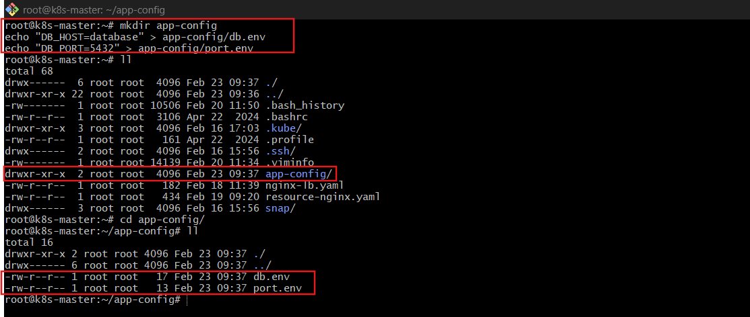
Step 2: Create ConfigMap from directory
kubectl create configmap app-config --from-file=app-config/
What happens?
- Each file becomes a key
- File contents become the value
Check it:
kubectl describe configmap app-config
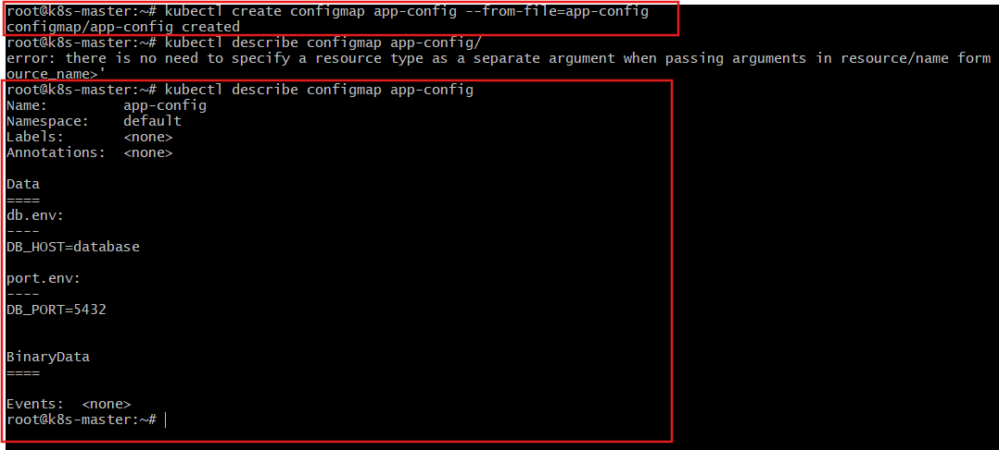
Step 3: Inject ConfigMap into Pod as Environment Variables
vi pod.yaml
apiVersion: v1
kind: Pod
metadata:
name: configmap-env-pod
spec:
containers:
- name: app
image: nginx
envFrom:
- configMapRef:
name: app-config
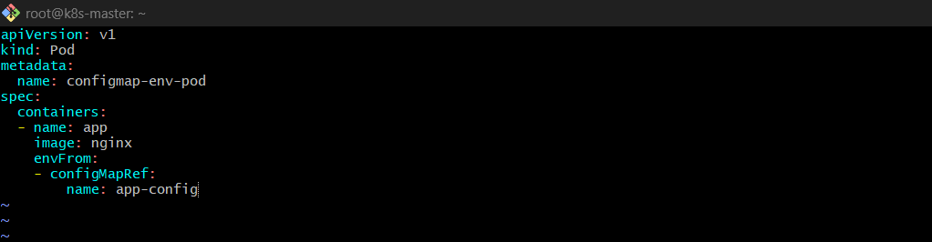
Apply it:
kubectl apply -f pod.yaml
Explanation
- envFrom imports all ConfigMap keys as environment variables.
- Each key becomes an environment variable inside the container.
Verify:
kubectl exec -it configmap-env-pod -- printenv
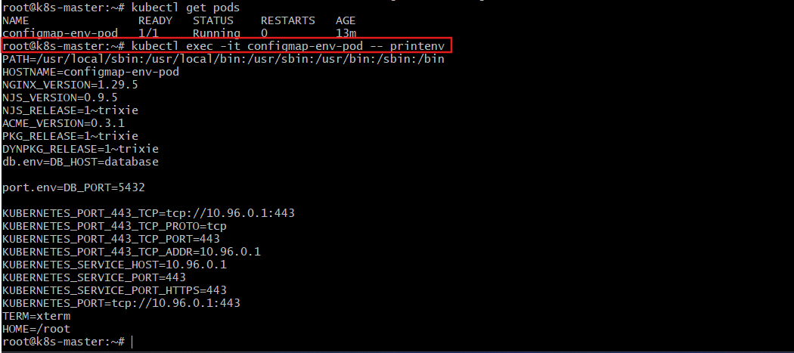

- Create a ConfigMap from a file and mount it as a volume inside a pod, ensuring the configuration data is available as files.
Create ConfigMap from File & Mount as Volume
Step 1: Create config file
echo "app.mode=production" > app.properties
Step 2: Create ConfigMap
kubectl create configmap app-file-config --from-file=app.properties
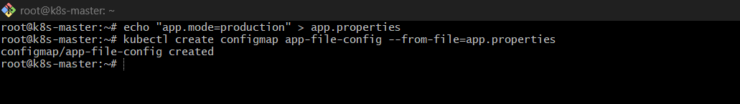
Step 3: Mount ConfigMap as Volume
vi pod.yaml
apiVersion: v1
kind: Pod
metadata:
name: configmap-volume-pod
spec:
containers:
- name: app
image: nginx
volumeMounts:
- name: config-volume
mountPath: /etc/config
volumes:
- name: config-volume
configMap:
name: app-file-config
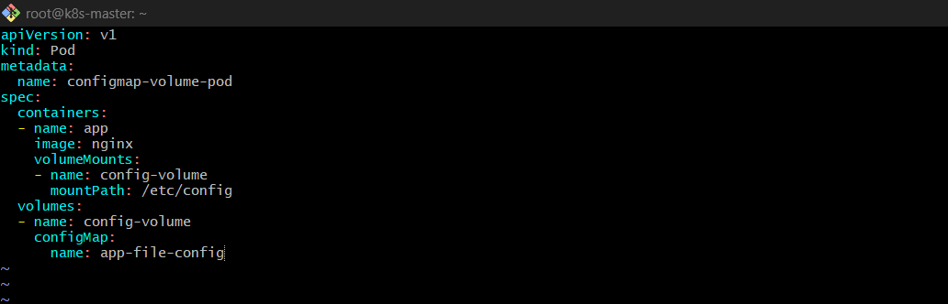
Apply:
kubectl apply -f pod.yaml
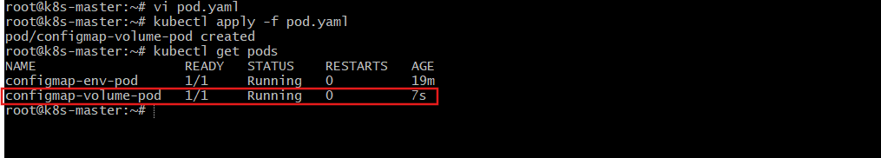
Explanation
- The ConfigMap is mounted as files.
- Each key becomes a file inside /etc/config.
Verify:
kubectl exec -it configmap-volume-pod -- ls /etc/config
kubectl exec -it configmap-volume-pod -- cat /etc/config/app.properties
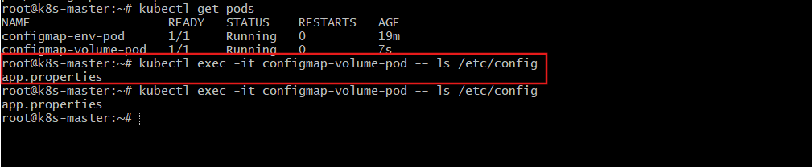
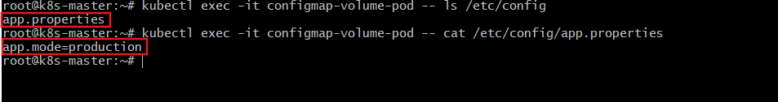
- Create a Secret with sensitive information (username and password) and inject it into a pod as environment variables.
Create Secret (username/password) & Inject as Environment Variables
Step 1: Create Secret
kubectl create secret generic db-secret \
--from-literal=username=admin \
--from-literal=password=MyPass123
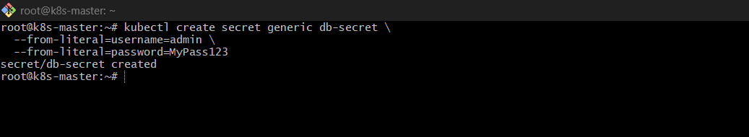
Step 2: Inject Secret as Environment Variables
vi pod.yaml
apiVersion: v1
kind: Pod
metadata:
name: secret-env-pod
spec:
containers:
- name: app
image: nginx
env:
- name: DB_USERNAME
valueFrom:
secretKeyRef:
name: db-secret
key: username
- name: DB_PASSWORD
valueFrom:
secretKeyRef:
name: db-secret
key: password
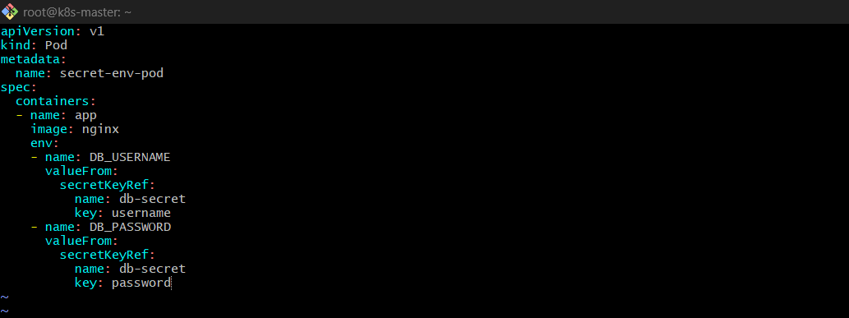
Apply:
kubectl apply -f pod.yaml
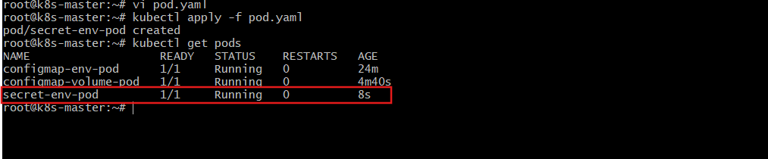
Explanation
- secretKeyRef injects specific secret keys.
- Secrets are base64 encoded in Kubernetes (not encrypted by default).
Verify:
kubectl exec -it secret-env-pod -- printenv
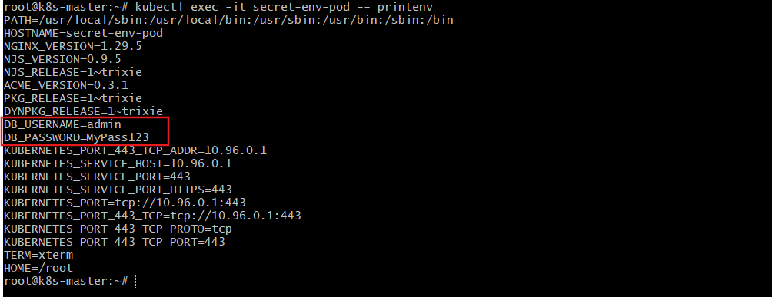
kubectl get secret
kubectl describe secret db-secret
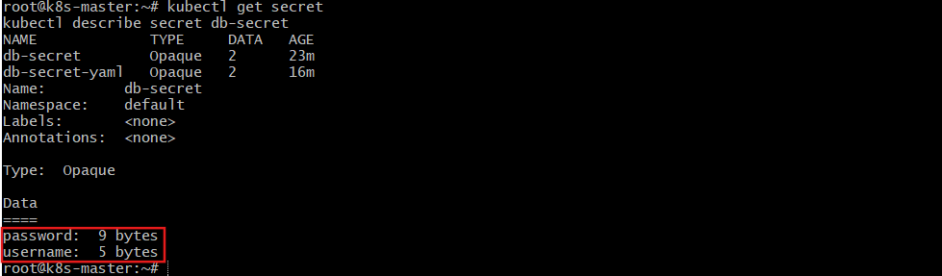
kubectl exec -it secret-env-pod -- printenv | grep DB_

- Create a Secret using a YAML file, mount it as a volume in a pod, and verify the specific Secret values are available as files.
Create Secret using YAML & Mount as Volume
Step 1: Create Secret YAML
Generate base64 values:
echo -n "admin" | base64
echo -n "MyPass123" | base64
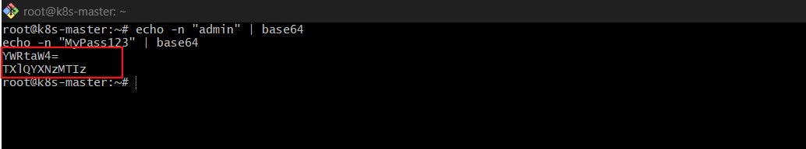
Secret YAML:
vi secret.yaml
apiVersion: v1
kind: Secret
metadata:
name: db-secret-yaml
type: Opaque
data:
username: YWRtaW4=
password: TXlQYXNzMTIz
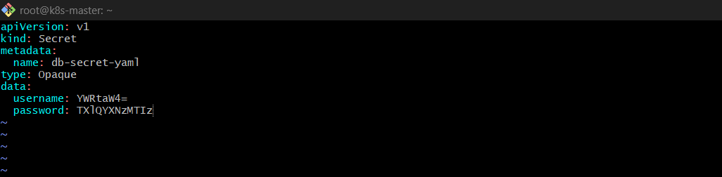
Apply:
kubectl apply -f secret.yaml
Step 2: Mount Secret as Volume
vi pod.yaml
apiVersion: v1
kind: Pod
metadata:
name: secret-volume-pod
spec:
containers:
- name: app
image: nginx
volumeMounts:
- name: secret-volume
mountPath: /etc/secret
readOnly: true
volumes:
- name: secret-volume
secret:
secretName: db-secret-yaml
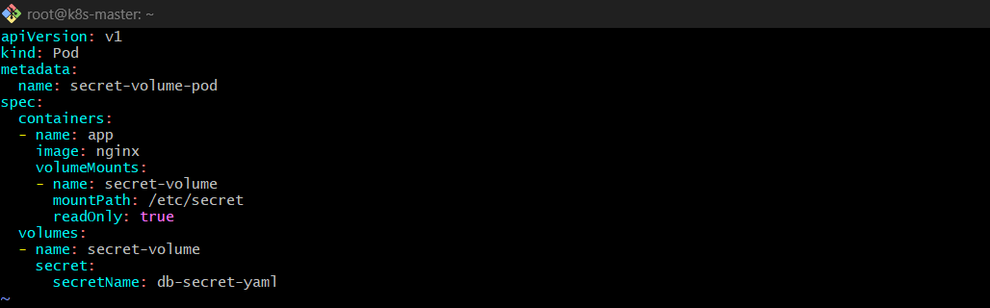
Apply:
kubectl apply -f pod.yaml
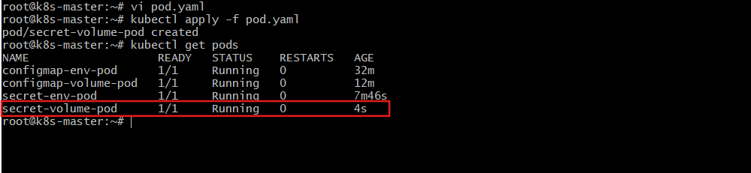
Explanation
- Each secret key becomes a file.
- Files are automatically decoded from base64.
- Mounted as read-only for security.
Verify:
kubectl exec -it secret-volume-pod -- ls /etc/secret
kubectl exec -it secret-volume-pod -- cat /etc/secret/username
- Inject a ConfigMap as environment variables and a Secret as files into the same pod, ensuring both are accessible within the pod.
Inject ConfigMap (env) + Secret (files) in Same Pod
Combined Pod YAML
vi combined.yaml
apiVersion: v1
kind: Pod
metadata:
name: combined-pod
spec:
containers:
- name: app
image: nginx
envFrom:
- configMapRef:
name: app-config
volumeMounts:
- name: secret-volume
mountPath: /etc/secret
readOnly: true
volumes:
- name: secret-volume
secret:
secretName: db-secret
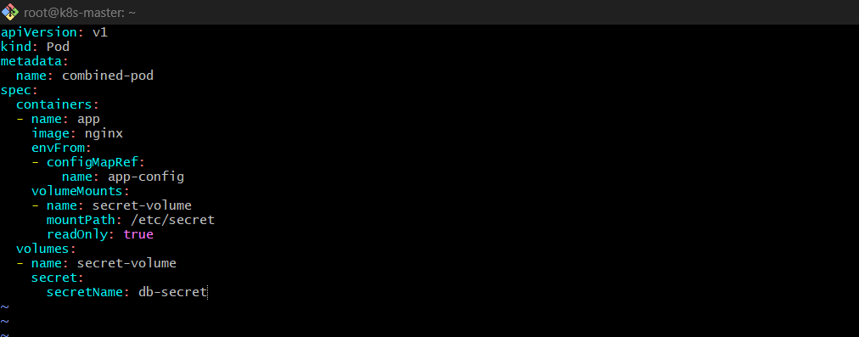
Apply:
kubectl apply -f combined.yaml
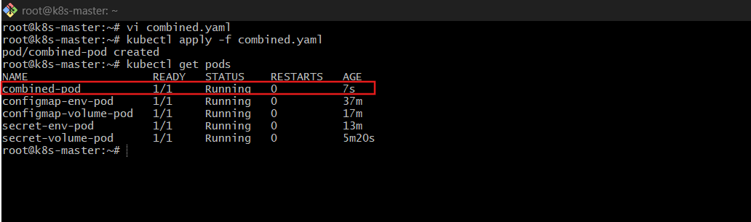
Explanation
Inside the pod:
- ConfigMap values → Environment variables
- Secret values → Files in /etc/secret
Verify:
kubectl exec -it combined-pod – printenv
kubectl exec -it combined-pod -- ls /etc/secret
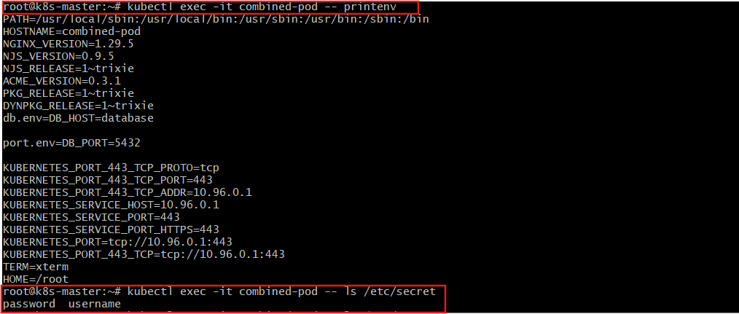
Validate Secret Content
kubectl exec -it combined-pod -- cat /etc/secret/password

